***PIZZA SALES SQL QUERY***

**KPIs:**

1. **Total Revenue:**

SELECT SUM(total_price) AS total_revenue FROM pizza_sales

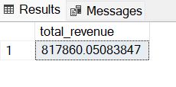

1. **Average order value:**

select sum(total_price)/count(distinct order_id) as average_order_value from pizza_sales

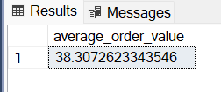

1. **Total pizza sold:**

select sum(quantity) as total_pizza_sold from pizza_sales

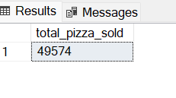

1. **Total Orders:**

select count (distinct order_id) as total_orders from pizza_sales

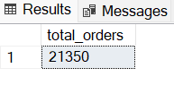

1. **Average Pizza per Order:**

select cast(sum(quantity) as decimal(10,2))/count (distinct order_id) as Average_Pizza_per_Order from pizza_sales

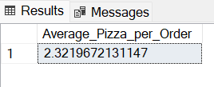

1. **Daily trend for total orders:**

select datename(dw,order_date) as order_day,count(distinct order_id) as total_orders

from pizza_sales

group by datename(dw,order_date)

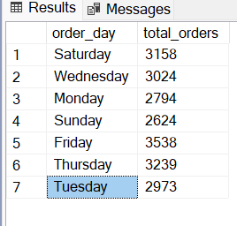

1. **Hourly trend for total orders:**

select datepart(hour,order_time) as hour_day,count(distinct order_id) as total_orders

from pizza_sales

group by datepart(hour,order_time)

order by datepart(hour,order_time)

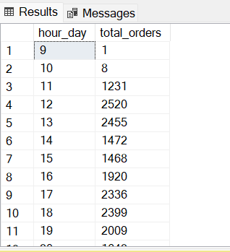

1. **Percentage of Sales by Pizza Category:**

select pizza_category, sum(total_price) as Total_sales, sum(total_price)*100 / (select sum(total_price) from pizza_sales) as PCT

from pizza_sales

group by pizza_category

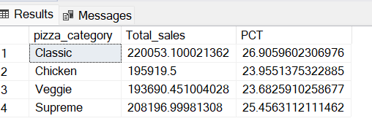

1. **Percentage of Sales by Pizza Size:**

select pizza_size, sum(total_price) as Total_sales, sum(total_price)*100 / (select sum(total_price) from pizza_sales) as PCT

from pizza_sales

group by pizza_size

order by PCT asc

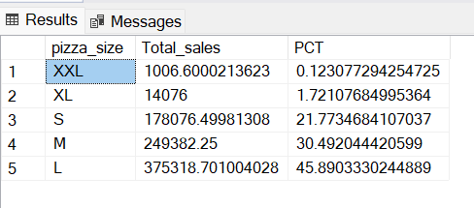

1. **Top Five best seller by pizza sold:**

select top 5 pizza_name, sum(quantity) as total_pizza_sold

from pizza_sales

group by pizza_name

order by total_pizza_sold desc

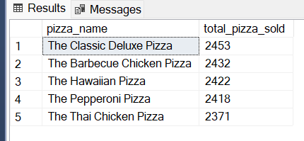

1. **Top Five Worst seller by pizza sold:**

select top 5 pizza_name, sum(quantity) as total_pizza_sold

from pizza_sales

group by pizza_name

order by total_pizza_sold asc

